Problem Solving Question Taken from Internet :- (Nested-if else)
In this scenario,
CASE 1 : the if statement checks if the customer is over 60 years old. If so, it checks if the visit time is between 2 pm and 5 pm. If both conditions are met, a 10% discount is applied.
CASE 2 : If not, no discount is applied.
Solution :-

CASE 1 : (both conditions are true) -
* Age and Visiting time both are applied !

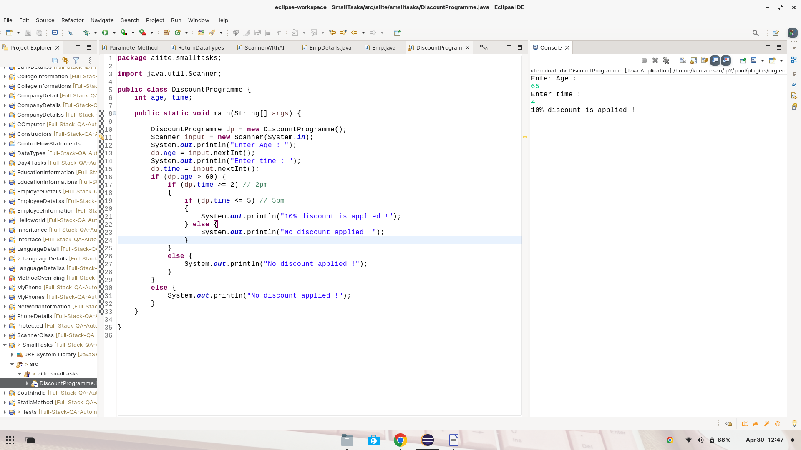

CASE 1 : (one condition true another false) -
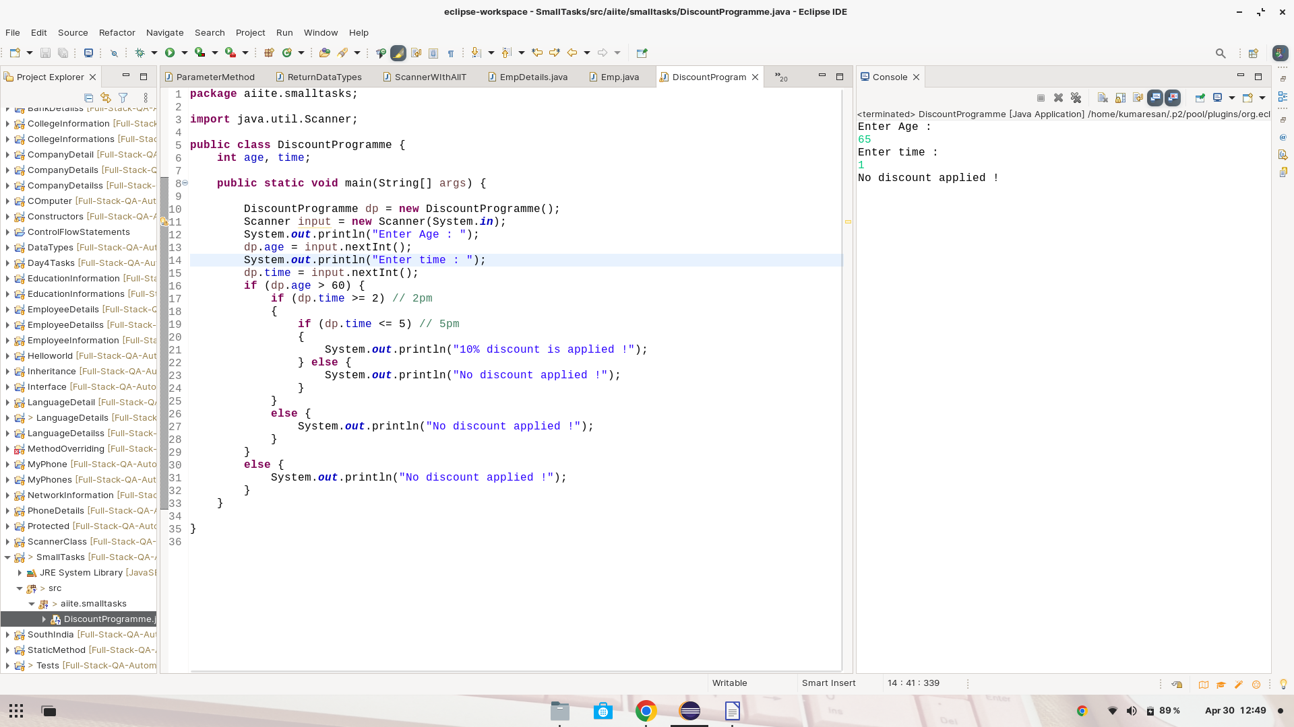
* Age applied but visiting time not !
* Visiting time applied and age is not !

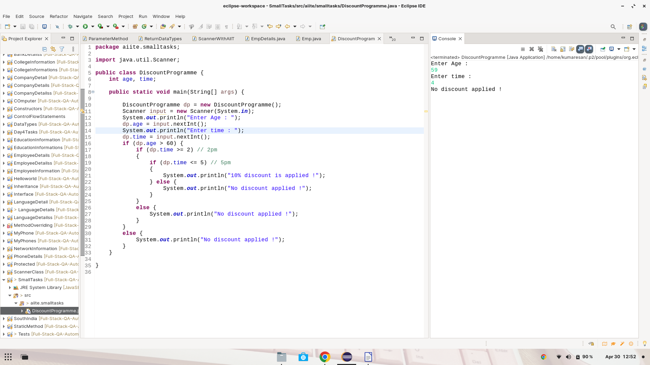
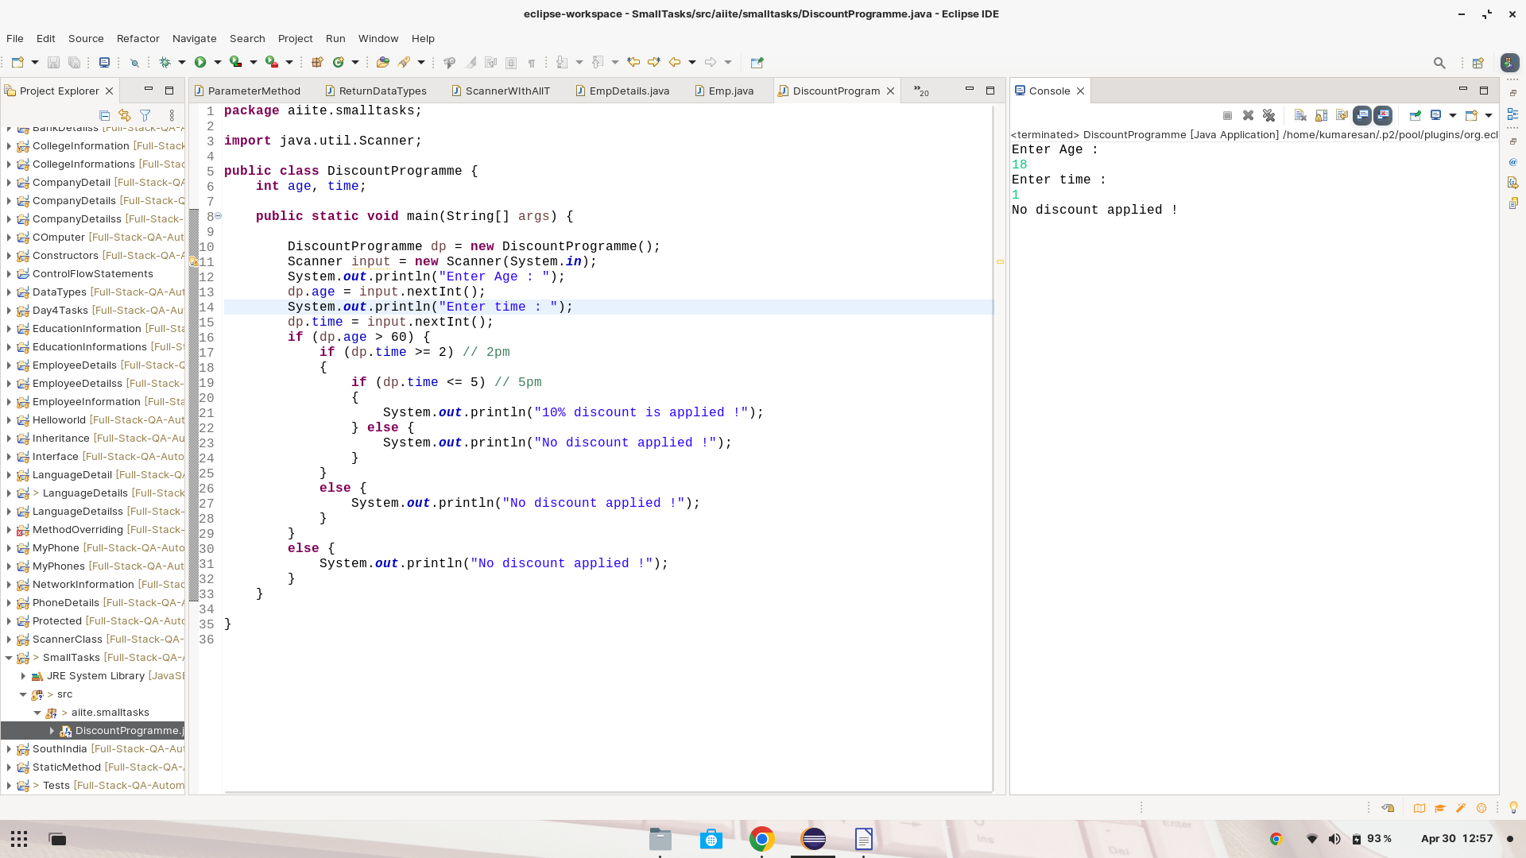
CASE 2 : (both condition are false)
Age and visiting time both are not applied !

